

Functional specification – VIGILANCE REPORTS AND RETURN

Document revision History

|  |  |  |  |  |
| --- | --- | --- | --- | --- |
| **Revision** | **Date** | **Prepared by** | **Reviewed by** | **Remarks** |
| V1 |  | Praven Kumar |  | First draft |
|  |  |  |  |  |
|  |  |  |  |  |
|  |  |  |  |  |

CONTENT

1 PURPOSE 4

2 BUSINESS REQUIREMENT & SPECIFICATIONS 4

3 FUNCTIONAL SOLUTION DESCRIPTION 5

3.1 CRIM CATEGORY 5

3.2 CONFIGURATION TYPE 5

3.3 CONTEXUAL DIAGRAM / REPRESENTATION OF DEVELOPMENT 6

3.4 SOLUTION WORKFLOW METHODOLOGY / LOGIC 6

3.5 SOLUTION DESCRIPTION STEP-BY-STEP APPROACH / EXECUTION 18

3.6 SCOPE TOOL SCENARIO’S UPDATE 19

3.7 DATA MIGRATIONS 19

4 TEST SCRIPT 20

4.1 TEST CASE -1: Employee Payment 20

4.2 TEST CASE – 2: Advance requested but not paid 20

4.3 TEST CASE -3: Absence creation 21

4.4 TEST CASE – 4: Same Exchange rate 22

4.5 TEST CASE – 5: Employee expense less than advance 22

4.6 TEST CASE – 6: Employee expense greater than advance 23

4.7 TEST CASE – 7: Reminder for non submission of expense sheet 24

4.8 TEST CASE – 8: Cancel absence 25

4.9 TEST CASE – 9: Transfer payments to payroll 26

4.10 TEST CASE – 10: Advance request is rejected 28

5 LIMITATIONS / ASSUMPTIONS 28

# PURPOSE

This document specifies how the defined **functions** shall be developed or how the application shall be customized to solve the business requirements.

The Solution Description defines what will be delivered. The solution is matched against the requirements described in the Requirements section.

The Delimitations describe what is explicitly not covered by this customization. Together with the Solution description, these sections delimit the extent of the functional addition agreed for implementation.

# BUSINESS REQUIREMENT & SPECIFICATIONS

|  |  |  |
| --- | --- | --- |
| Requirement  CRIM ID | Description  CRIM Description | BPT Solution Description |
|  | **Reports and Return** | Screens will be provided to Corporate Vigilance in link with Divisional Vigilance where reports and return details will be submitted for review. |

In HAL, Vigilance department has a vital role in inspecting the business process and transactions of HAL in all divisions, As part of Vigilance department reporting to CVO and CVI , Various reports are gathered from respective Divisions periodically. These reports will be submitted by the respective Divisions upon approval from their respective complex. This process is called as Vigilance Reports and Return.

The following business scenarios should be factored.

* IFS Generated reports and manually generated reports are expected to be submitted.
* IFS Generated report data is expected to be automatically captured for Vigilance submission.
* Report frequency can be Monthly / Quarterly / Half yearly / Annual.
* Responsible Divisional level Department should submit the listed reports as per the list and frequency with proper approval to corporate.

# FUNCTIONAL SOLUTION DESCRIPTION

In HAL, business requirements will be mapped through Newly developed Vigilance Report and Return functionality. End to end New Development with IFS standard functionalities to address the maximum requirements of HAL.

## CRIM CATEGORY

Some of the

|  |
| --- |
|  |
| CONFIGURATION |
| REPORT |
| INTERFACE |
| MODIFICATION |

## CONFIGURATION TYPE

|  |
| --- |
| CONFIGURATION TYPE |
| ~~Custom Logical Unit~~ |
| ~~Custom Field~~ |
| ~~Custom Event~~ |
| ~~Custom Menu~~ |
| ~~Conditional Field~~ |

**Note: Configuration Type is applicable to CRIM Category ‘CONFIGURATION’**

## CONTEXUAL DIAGRAM / REPRESENTATION OF DEVELOPMENT

* New Custom Logical Unit / Table for holding the Report Execution data to be created
* New Screen to Configure the Report Master data definition with various report parameters and column storage mapping. This will be handled by the Corporate Vigilance Team.
* 5 New Sub Tabs to be developed in Report Master data screen to map the below details.
  + Sub Tab 1 to be developed to map the Source column with Data column & Data Template from Report output.
  + Sub Tab 2 To define the user access with status change power against the report.
  + Sub Tab 3 To Define the parameters of the report to identify the last date of submission.
  + Sub Tab 4 To exhibit the Periods data as a ready only data.
  + Sub Tab 5 to define all the divisions and sites for which reports to be extracted.
* New Screen to Generate and process periodical reports which will be initiated by the Divisions.
* New Schedule Database Task to generate the Report Execution Header records periodically. This task should be scheduled for last day of every month
* New Lobby element to display the pending report submission at various Divisions.

IFS Path / Aurena Path: Vigilance Management System/Vigilance Reports and Return > Report Configuration

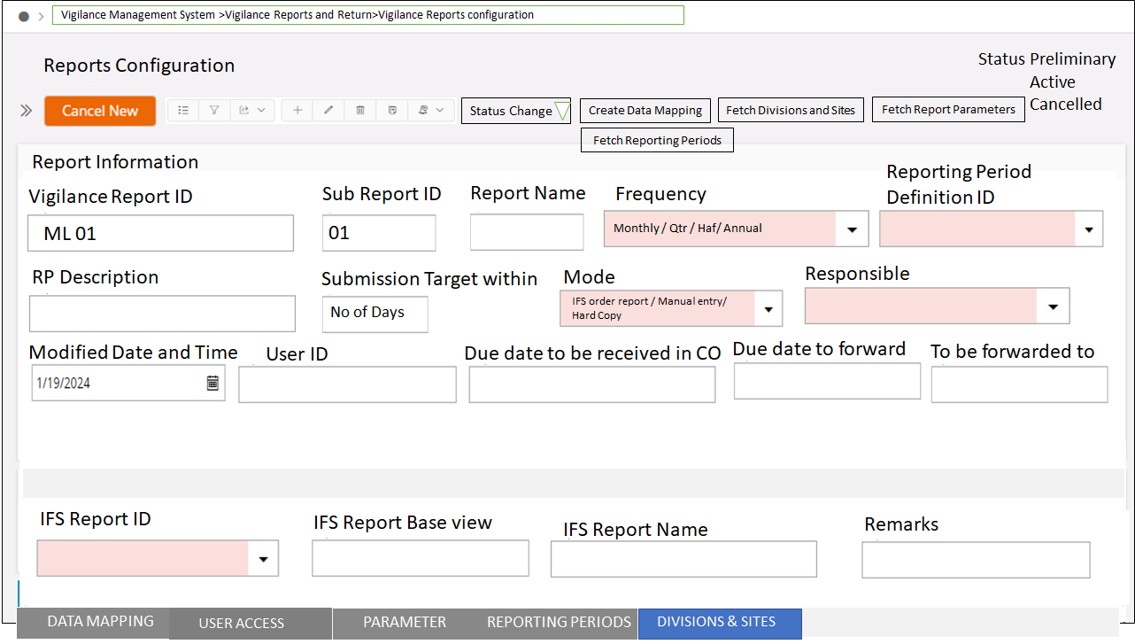

IFS Path / Aurena Path: Vigilance Management System/Vigilance Reports and Return > Vigilance Reports and Return Execution

## SOLUTION WORKFLOW METHODOLOGY / LOGIC

**Development Framework:**

### New Custom Logical Unit/ Table for storing the Report execution data

New LU Name – CVigRepExeData

| Sl no | Tab Label (As per IFS Standard) | Insert | Mandatory | Update | Query able | List of Value | Format & Length | Remarks |
| --- | --- | --- | --- | --- | --- | --- | --- | --- |
| 1 | Vigilance Report ID | Y | Y | N | Y | N | VARCHAR2 20 | Combination Primary Key |
| 2 | Sub Report ID | Y | Y | N | Y | N | VARCHAR2 10 | Combination Primary Key |
| 3 | Source View Name | Y | Y | N | N | N | VARCHAR2 30 |  |
| 4 | Result_key | Y | Y | N | N | N | Number |  |
| 5 | Execution Date | Y | Y | N | N | N | Date Time |  |
| 6 | Reporting Period Definition ID | Y | Y | N | Y | N | VARCHAR2 100 |  |
| 7 | Reporting Year Period | Y | Y | N | Y | N | Number |  |
| 8 | Reporting Year Period Desc | Y | Y | N | N | N | VARCHAR2 100 |  |
| 9 | User_id | Y | Y | N | Y | N | VARCHAR2 30 |  |
| 10 | Division | Y | Y | N | N | N | VARCHAR2 30 |  |
| 11 to 50 | S1 to S50 | Y | N | N | N | N | Varchar2 4000 |  |
| 51 to 75 | N1 to N25 | Y | N | N | N | N | Number |  |
| 76 to 90 | D1 to D15 | Y | N | N | N | N | Date time |  |

Business Logic for this LU has been defined in the Report Execution section at later part of this document.

### New Screen Label Name “Report Configuration” which will consist of various new foelds and fields and 5 sub tabs. “Report Configuration” is a screen where the user will define the configuration and mapping of column of the reports which is to be submitted by the Division department.

New LU Name – CVigRepConfig

| Sl no | Tab Label (As per IFS Standard) | Insert | Mandatory | Update | Query able | List of Value | Format & Length | Remarks |
| --- | --- | --- | --- | --- | --- | --- | --- | --- |
| 1 | Vigilance Report ID | Y | Y | N | Y | N | VARCHAR2 20 | Combination Primary Key |
| 2 | Sub Report ID | Y | Y | N | Y | N | VARCHAR2 10 | Combination Primary Key |
| 3 | Report Name | Y | Y | Y | Y | N | VARCHAR2 500 |  |
| 4 | IFS Report ID | Y | N | Y | Y | Y | VARCHAR2 30 | Conditional mandatory |
| 5 | IFS Report Name | Y | N | Y | Y | N | VARCHAR2 50 |  |
| 6 | Mode of Report | Y | Y | Y | Y | N | VARCHAR2 20 | Custom Enumeration  IFS order report / Manual entry/ Hard Copy |
| 7 | Responsible | Y | Y | Y | Y | Y | VARCHAR2 50 | LOV from Person |
| 8 | Frequency | Y | Y | Y | Y | N | VARCHAR2 20 | Custom Enumeration  Monthly / Quarterly / Half Yearly / Annual |
| 9 | Reporting Period Definition ID | Y | Y | Y | Y | Y | VARCHAR2 100 |  |
| 10 | RP Description | Y | Y | Y | N | N | VARCHAR2 200 |  |
| 11 | Submission Target within | Y | Y | Y | N | N | NUMERIC | Should be an integer |
| 12 | To be forward to | Y | Y | Y | Y | N | VARCHAR2 500 |  |
| 13 | Modified Date and Time | N | N | N | N | N | DATE TIME | Not editable from front end |
| 14 | User ID | Y | Y | N | N | N | VARCHAR2 30 | Not editable from front end |
| 15 | Due Date to be received in CO | Y | N | Y | N | N | VARCHAR2 200 |  |
| 16 | Due Date to be forward to | Y | N | Y | N | N | VARCHAR2 200 |  |
| 17 | Remarks | Y | N | Y | N | N | VARCHAR2 1000 |  |
| 18 | Status | Y | Y | Y | N | N | VARCHAR2 200 | Status Values :  Preliminary, Active, Obsolete |

**Business Logic:**

In the Report Configuration screen (Add, Delete & Edit button to be provided along with Filter option to be provided). User will click the Add button and will enter the details.

1. Vigilance Report ID and Sub Report ID will be entered by the user, which will be Free fields.
2. “IFS Report ID” should fetch the LOV of View Name: Report_definition. The Report_id field should be fetched and stored.
3. The corresponding Report Title from View Name: Report_definition should be fetched into “IFS Report Name” and should not be editable.
4. “Mode of Report” is a LOV filed where the user will select from the provided LOVs “IFS Order Report”/ “Manual Entry” / “Hard Copy”
   1. IFS Order Report (will fetch the report details directly from the IFS).
   2. Manual Entry (The user will enter the data based on the fields provided.
   3. Hard Copy: The user will enter the data and enclose the proof.
5. Based on the selection of “Mode of Report”, if the Mode is “IFS Order report”, then the “IFS Report ID” field should be mandatory. Similarly, if it is not an “IFS Order report”, the “IFS Report ID” should not have values.
6. “Responsible” should be from the Persion_id field of LOV Person_info
7. The “Frequency” user should define the periodicity of the reports from the Divisions.
8. “Reporting Period Definition ID” LOV should be from Reporting Period Definitions (Path: Accounting Rule > Reporting Period > Reporting Period Definitions.) view – rpd_identity
9. The corresponding Description should be fetched into the “RP Description”
10. “Submission Target Within” will be filled in by the user.
11. “To be Forwarded To” is a free field where the user will enter the consolidated report to be sent to whom.
12. “Modified Date & Time” is the latest date and time when the Report Configuration was created or modified.
13. “User ID” the user who created/modified the Report Configuration
14. “Due Date to be received in CO” free text where the user will enter the details
15. “Due Date to Forward” free text where the user will enter the details
16. “Remarks” free text where the user will enter any remarks if any.
17. When a new record is created, the status should be “Preliminary” by default. Once the user decides to change the status, they will use action buttons.
18. The edit button should be restricted if the status is “Active” or “Obsolete”.
19. When making the status “Active”, the system should verify that data exists in all the new tab pages. This is applicable only for “Mode of Report” – “IFS Order Report”.
20. For “Mode of Report” – “Manual” and “Hard Copy”, the “User Access” and “Reporting Periods” tabs to have data before the status is changed to “Active”.

### Tab – “Data Mapping” for “Report Configuration

New LU Name - CVigRepDMap

| Sl no | Tab Label (As per IFS Standard) | Insert | Mandatory | Update | Queryable | List of Value | Format & Length | Remarks |
| --- | --- | --- | --- | --- | --- | --- | --- | --- |
| 1 | Vigilance Report ID | Y | Y | N | Y | N | VARCHAR2 20 | Combination Primary Key  Not to be displayed in Front end |
| 2 | Sub Report ID | Y | Y | N | Y | N | VARCHAR2 10 | Combination Primary Key  Not to be displayed in Front end |
| 3 | Source View Name | Y | Y | N | N | N | VARCHAR2 30 |  |
| 4 | Source Column | Y | Y | N | Y | Y | VARCHAR2 30 |  |
| 5 | Source Data Type | Y | Y | N | Y | Y | VARCHAR2 30 |  |
| 6 | Target Column | Y | Y | N | Y | Y | VARCHAR2 30 |  |
| 7 | Target Data Type | Y | Y | N | Y | Y | VARCHAR2 30 |  |
| 8 | Exclude | Y | Y | Y | N | N | VARCHAR2 30 | Toggle Button (Boolean)  True or False |
| 9 | Sum Total | Y | Y | Y | N | N | VARCHAR2 30 | Toggle Button (Boolean)  True or False |

**Business Logic:**

In the Report Configuration screen, the Tab for Data Mapping is to be provided.

In the Header of Report Configuration, a new Button “Create Data Mapping” is to be provided. Upon clicking the button (which should work only in Preliminary status), the data mapping between the Report Result data (IFS Order Report ID View) and the Vigilance Report Execution Data table to be automatically created as per the following logic. Only the Edit button is to be provided along with the Filter option.

1. Based on the IFS Report ID base view, fetch the columns from the View along with the data types.

Ex. HRP_ABS_REP (Absence Overview report) will have the following columns

|  |  |
| --- | --- |
| **Source Column Name** | **Source Data Type** |
| Result_key | number |
| Row_no | number |
| Company_id | Varchar2(4000) |
| Org_code | Varchar2(4000) |
| Org_name | Varchar2(4000) |
| Emp_no | Varchar2(4000) |
| Fname | Varchar2(4000) |
| Absence_type_id | Varchar2(4000) |
| Abs_duration | number |

1. Fetch all the columns from the LU “CVigRepExeData”, between S1 to S50, N1 to N25, and D1 to D15 to use a target column.
2. Map each column in the report with one of the target columns based on the data type.

|  |  |  |  |
| --- | --- | --- | --- |
| **Source Column Name** | **Source Data Type** | **Target Column Name** | **Target Data Type** |
| Result_key | number | N1 | number |
| Row_no | number | N2 | number |
| Company_id | Varchar2(4000) | S1 | Varchar2(4000) |
| Org_code | Varchar2(4000) | S2 | Varchar2(4000) |
| Org_name | Varchar2(4000) | S3 | Varchar2(4000) |
| Emp_no | Varchar2(4000) | S4 | Varchar2(4000) |
| Fname | Varchar2(4000) | S5 | Varchar2(4000) |
| Absence_type_id | Varchar2(4000) | S6 | Varchar2(4000) |
| Abs_duration | number | N3 | number |

1. Insert this mapping data into the LU “CVigRepDMap” along with the Primary Key fields from the Header LU “CVigRepConfig”.
2. By default, the Exclude field is to be made “False” and the user can be allowed to change this.
3. By default, the Total Field is to be made “False” for all records and the user can be allowed to change this only for the “Target Data type” field with the value “Number”

### Tab – “Divisions and Sites” Report Configuration

New LU Name - CVigRepSites

| Sl no | Tab Label (As per IFS Standard) | Insert | Mandatory | Update | Queryable | List of Value | Format & Length | Remarks |
| --- | --- | --- | --- | --- | --- | --- | --- | --- |
| 1 | Vigilance Report ID | Y | Y | N | Y | N | VARCHAR2 20 | Combination Primary Key  Not to be displayed in Front end |
| 2 | Sub Report ID | Y | Y | N | Y | N | VARCHAR2 10 | Combination Primary Key  Not to be displayed in Front end |
| 3 | Division | Y | Y | Y | Y | Y | VARCHAR2 30 |  |
| 4 | Division Name | N | N | N | N | N | VARCHAR2 100 | Read-only |
| 5 | Site | Y | Y | Y | Y | N | VARCHAR2 30 |  |
| 6 | Site Name | N | N | N | N | N | VARCHAR2 100 | Read-only |
| 7 | Exclude | Y | Y | Y | Y | N | VARCHAR2 10 | Boolean  True or False  Default - False |

**Business Logic:**

In the Report Configuration screen, a Tab for “Divisions and Site” is to be provided.

Only the Edit button is to be provided along with the Filter option.

In the Header of Report Configuration, a new Button “Create Divisions and Sites” is to be provided. Upon clicking the button (which should work only in Preliminary status), the Divisions and the Sites to be automatically created as per the following logic.

1. Expand the Graphical Org Structure of type “Matrix”
2. Identify all the Org IDs with Org Level 30 and consider them as divisions.
3. Expand the Org Structure further down below with the Divisions Org ID as a parent and identify the Child Org IDs with Org Level 40 and consider them as Sites.
4. Insert the Divisions and Sites data into this LU. If One division has multiple Sites, one record is to be created for each Division – Site combination.
5. By default, the Exclude field should be set to False. If the user wishes, they should be able to manually change it to True (toggle button)

Org Structure Screens for reference (No customization required in this FS for these screens)

### Tab – “User Access” for Report Configuration

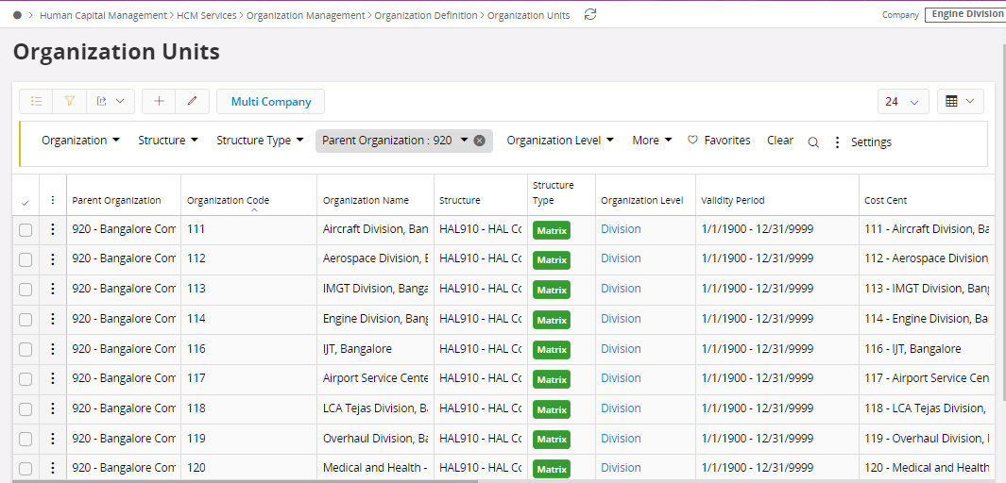

New LU Name - CVigRepAccess

| Sl no | Tab Label (As per IFS Standard) | Insert | Mandatory | Update | Queryable | List of Value | Format & Length | Remarks |
| --- | --- | --- | --- | --- | --- | --- | --- | --- |
| 1 | Vigilance Report ID | Y | Y | N | Y | N | VARCHAR2 20 | Combination Primary Key  Not to be displayed in Front end |
| 2 | Sub Report ID | Y | Y | N | Y | N | VARCHAR2 10 | Combination Primary Key  Not to be displayed in Front end |
| 3 | User ID | Y | Y | Y | Y | Y | VARCHAR2 30 | Combination Primary Key |
| 4 | Username | Y | Y | Y | Y | N | VARCHAR2 200 | Read-only |
| 5 | Complex | Y | Y | Y | N | Y | BOOLEAN | Combination Primary Key  % wildcard should be allowed in addition to LOV |
| 6 | Division | Y | Y | Y | N | Y | BOOLEAN | Combination Primary Key  % wildcard should be allowed in addition to LOV |
| 7 | Create | Y | Y | Y | N | N | BOOLEAN | Toggle Button  True or False |
| 8 | Freeze/Unfreeze | Y | Y | Y | N | N | BOOLEAN | Toggle Button  True or False |
| 9 | Approved/Revert | Y | Y | Y | N | N | BOOLEAN | Toggle Button  True or False |
| 10 | Verified | Y | Y | Y | N | N | BOOLEAN | Toggle Button  True or False |
| 11 | Vigilance User | Y | Y | Y | Y | N | VARCHAR2 10 | Boolean  True or False  Default - False |

**Business Logic:**

In the Report Configuration screen, a Tab for Reports User Access is to be provided.

Add, Delete & Edit buttons are to be provided along with the Filter option.

1. The user should create a new record for each User to whom the access for Report Execution is to be provided.
2. The User ID field should be a LOV from fnd_user
3. The user name should be fetched from the same view based on the User ID
4. The Complex Field should be an LOV from the Graphical Organization Structure with Structure Type “Matrix” and the Organization level as 20
5. % wild card should be allowed in addition to the LOV values. I.e. User will enter “%” or any specific Org ID from LOV against the Complex field.
6. The Division Field should be an LOV from the Graphical Organization Structure with Structure Type “Matrix” and the Organization level as 30. Filter the Divisions for the selected Complex (Org ID) in the LOV
7. % wild card should be allowed in addition to the LOV values. I.e. User will enter “%” or any specific Org ID from LOV against the Complex field.
8. Create should be a toggle button with True or False Boolean values. Users should be able to modify it. The default value should be False.
9. Freeze/Unfreeze should be a toggle button with True or False Boolean values. Users should be able to modify it. The default value should be False.
10. Approve/Revert should be a toggle button with True or False Boolean values. Users should be able to modify it. The default value should be False.
11. Verified should be a toggle button with True or False Boolean values. Users should be able to modify it. The default value should be False.
12. By default, the Vigilance user field should be set to False. If the user wishes, they should be able to manually change it to True (toggle button)
13. Duplicates should not be allowed for the combination of primary keys defined in the table.

### Tab – “Parameter” for Report Configuration

New LU Name - CVigRepParam

| Sl no | Tab Label (As per IFS Standard) | Insert | Mandatory | Update | Queryable | List of Value | Format & Length | Remarks |
| --- | --- | --- | --- | --- | --- | --- | --- | --- |
| 1 | Vigilance Report ID | Y | Y | N | Y | N | VARCHAR2 20 | Combination Primary Key  Not to be displayed in Front end |
| 2 | Sub Report ID | Y | Y | N | Y | N | VARCHAR2 10 | Combination Primary Key  Not to be displayed in Front end |
| 3 | Parameter Name | Y | Y | N | Y | N | VARCHAR2 400 | Read-only |
| 4 | Parameter Value Static | Y | N | Y | Y | N | VARCHAR2 4000 |  |
| 5 | Parameter Method (PLSQL Function) | Y | N | Y | N |  | VARCHAR2 200 |  |

**Business Logic:**

In the Report Configuration screen, Tab for “Parameters” to be provided.

Only the Edit button is to be provided along with the Filter option.

In the Header of Report Configuration, a new Button “Fetch report parameters” is to be provided. This button will work only for IFS Order reports. Upon clicking the button (which should work only in Preliminary status), the input parameters of the IFS Order report should be fetched and created as rows as per the following logic.

1. Each Parameter will be created as a row
2. The parameter value static will be null while creation and will be updated by the user
3. The parameter Method will be null while creation and will be updated by the user

### Tab – “Reporting Period” for Report Configuration

New LU Name - CVigRepPeriod

| Sl no | Tab Label (As per IFS Standard) | Insert | Mandatory | Update | Queryable | List of Value | Format & Length | Remarks |
| --- | --- | --- | --- | --- | --- | --- | --- | --- |
| 1 | Vigilance Report ID | Y | Y | N | Y | N | VARCHAR2 20 | Combination Primary Key  Not to be displayed in Front end |
| 2 | Sub Report ID | Y | Y | N | Y | N | VARCHAR2 10 | Combination Primary Key  Not to be displayed in Front end |
| 3 | RPD_ID | Y | Y | N | Y | N | VARCHAR2 100 |  |
| 4 | RPD_Year | Y | Y | N | Y | N | Number |  |
| 5 | Year_Period_no | Y | Y | N | Y | N | Number |  |
| 6 | RPD_period | Y | Y | N | Y | N | Number |  |
| 7 | From_date | Y | Y | N | Y | N | Date |  |
| 8 | Until_date | Y | Y | N | Y | N | Date |  |
| 9 | String_attribute1 | Y | Y | N | Y | N | VARCHAR2 100 |  |

**Business Logic:**

In the Report Configuration screen, the Tab for “Reporting Periods” is to be provided.

No Edit or add option is required. Only the Filter option is required.

In the Header of Report Configuration, a new Button “Fetch reporting Periods” is to be provided. This button will work only for all report modes. Upon clicking the button (which should work only in Preliminary status), the reporting periods from view RPD_PERIOD to be fetched and inserted. If this button is pressed after creating records in this tab, it should delete the records with Sysdate falling between “From date” and “Until Date” and greater (future periods) and recreate fresh records. Past Periods records should not get deleted after creating them for the first time.

### New Screen Label Name “Report Execution” which will consist of new fields and 1 sub-tab. “Report Configuration” is a screen where the user will define the configuration and mapping of columns of the reports which is to be submitted by the Division department.

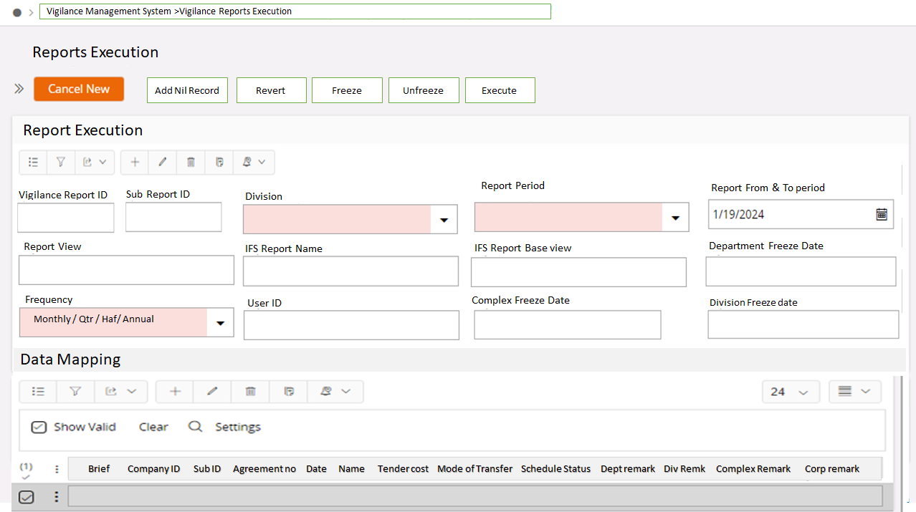

New LU Name - CVigRepExeHdr

| Sl no | Tab Label (As per IFS Standard) | Insert | Mandatory | Update | Queryable | List of Value | Format & Length | Remarks |
| --- | --- | --- | --- | --- | --- | --- | --- | --- |
| 1 | Vigilance Report ID | Y | Y | N | Y | N | VARCHAR2 20 | Combination Primary Key |
| 2 | Sub Report ID | Y | Y | N | Y | N | VARCHAR2 10 | Combination Primary Key |
| 3 | RPD_ID | Y | Y | N | Y | N | VARCHAR2 100 | Read-only |
| 4 | RPD_Year | Y | Y | N | Y | N | Number | Read-only |
| 5 | Year_Period_no | Y | Y | N | Y | N | Number | Read-only |
| 6 | RPD_period | Y | Y | N | Y | N | Number | Read-only |
| 7 | From_date | Y | Y | N | Y | N | Date | Read-only |
| 8 | Until_date | Y | Y | N | Y | N | Date | Read-only |
| 9 | String_attribute1 | Y | Y | N | Y | N | VARCHAR2 100 | Read-only |
| 10 | Division | Y | Y | N | Y | N | VARCHAR2 30 |  |
| 11 | User ID | Y | Y | N | N | N | VARCHAR2 30 | Read-only |
| 12 | Department Freeze Date | Y | N | Y | N | N | Date Time | Read-only |
| 13 | Division Freeze Date | Y | N | Y | N | N | Date Time | Read-only |
| 14 | Complex Freeze Date | Y | N | Y | N | N | Date Time | Read-only |
| 15 | Corporate Verified Date | Y | N | Y | N | N | Date Time | Read-only |
| 16 | Mode of Report | Y | Y | Y | Y | N | VARCHAR2 20 | Read-only |
| 17 | Frequency | Y | Y | Y | Y | N | VARCHAR2 20 | Read-only |

**Business Logic for Header Creation:**

New Scheduled task to generate the periodical Report Execution header. This will act as a pending event for the respective user departments in the Divisions to execute the reports and submit the data to the Vigilance department.

Steps in the Background Job

1. Loop all the reports in the “Reports Configuration” along with “Reporting periods” for each report. Join it with each unique “Division”. (Multiple sites under each division can be ignored and one division can be considered once).
2. Create a Report Execution Header for each of the reports for the periods where the sysdate falls within the reporting period (From date and Until date) for each division
3. All the mandatory field data can be mapped one to one from “Report Configuration” to “Report Execution”

**Business Logic for Header Modification:**

The Header section fields should not be editable through front-end fields. The update should only happen through the Action buttons.

Status field Logic

Action/ Status Button :

6 Status machine to be developed, as listed below:

1. “Report Not Generated” – The user is yet to execute the report data or manually upload or Document not attached.
2. “Report in Department” – The user has started entering the data in the screen, but not yet frozen.
3. “Reports in Division” – The Divisional Department user after filling the data has submitted the data to the next level by clicking the “Freeze” button.
4. “Reports in Complex” – The Divisional Vigilance user after checking the data has submitted the data to the next level by clicking the “Freeze” button. Incase if the Divisional Vigilance user not satisfied with the submitted data, can return it to the previous level by clicking “Unfreeze” the status will be “Report in Department”.
5. Approve data – “Reached Corporate” – The Complex Vigilance user after checking the submitted data by Division, can move it to next level by click the “Approve” button. Incase if the Complex Vigilance user not satisfied with the submitted data, can return it to the previous level by clicking “Revert” button the status will be “Report in Division”.
6. Verified Data – “Verified”- The Corporate user will verify the submitted data by complex and they will click the button “Verified”.

Action Button Logic

|  |  |
| --- | --- |
| Execute | * Should be highlighted only the Report mode is “IFS Order report”. * Should be highlighted only if the Department Freeze Date is null * The Order Report should be executed using the Input parameters connected in the Report Configuration either with Static Values or using PLSQL functions as specified in the Report configuration * Once the report is executed, the result data for the given execution (result key) should be inserted in the new LU-“ CVigRepExeDtl”. For mapping the fields use the Report Configuration Field Mapping tab by comparing the source and target mappings. * If the Execute button is pressed more than once, remove the existing data for the given report execution header data in the CVigRepExeDtl LU, re-execute the order report, and create fresh data. |
| Add Nil Record | * Should be highlighted only if the Report Freeze date is null and no records exist in the Report Execution detail. * If the Report mode is “IFS Order report” : Upon clicking, should execute the order report as per Execute Action button first. If no records are generated in Order report, then this should insert one record with blank value * If the Report mode is not “IFS Order report” : Upon clicking, this should insert one record with blank value. |
| Freeze | * When the “Department Freeze Date” is null and the Non-Vigilance user is clicking this button, the status should change to “Reports in Division” * When the “Division Freeze Date” is null and the Vigilance user is clicking this button, the status should change to “Reports in Complex” * When the “Complex Freeze Date” is null and the Vigilance user is clicking this button, the status should change to “Reached Corporate” |
| Un-freeze | * When the “Department Freeze Date” is not null and the Vigilance user is clicking this button, the status should change to “Reports in Department” * When the “Division Freeze Date” is not null and the Vigilance user is clicking this button, the status should change to “Reports in Division” * When the “Complex Freeze Date” is not null and the Vigilance user is clicking this button, the status should change to “Reports in Complex” |

**Business Reversals during workflow:**

Handled through Action buttons

**Impact On Other Modules:**

Nil

**Result / Business Value:**

Online Centralized Vigilance Reports and Return

## SOLUTION DESCRIPTION STEP-BY-STEP APPROACH / EXECUTION

|  |  |
| --- | --- |
| **STEP #** | **Description** |
| Step #1 |  |
| Step #2 |  |
| Step #3 |  |
| Step #4 |  |
| Step #5 |  |
| Step #6 |  |
| Step #7 |  |
| Step #8 |  |
| Step #9 |  |
| Step #10 |  |

## SCOPE TOOL SCENARIO’S UPDATE

|  |  |
| --- | --- |
| Scenario ID | Description |
| 3.1.7 |  |

## DATA MIGRATIONS

Impact on the data collections and migrations as applicable to be updated as below.

* Basic Data Template
* Master Data Template
* Transaction Template

# TEST SCRIPT

How to Test the Developed Modification. (Test No’s as applicable)

* Steps to Create Case
* How to test the modifications using IFS
* Expected Result

## TEST CASE -1: Employee Payment

|  |  |
| --- | --- |
| Test ID | Test Description |
| 1 |  |

## TEST CASE – 2: Advance requested but not paid

|  |  |
| --- | --- |
| Test ID | Test Description |
| 2 |  |

## TEST CASE -3: Absence creation

|  |  |
| --- | --- |
| Test ID | Test Description |
| 3 |  |

## TEST CASE – 4: Same Exchange rate

|  |  |
| --- | --- |
| Test ID | Test Description |
| 4 |  |

# LIMITATIONS / ASSUMPTIONS